Oxford Fire Department Capstone Written Report

Lily Douthat, Anton Martinez Dominguez, RJ Worrall, Mirza Baig
douthalm@miamioh.edu, marti964@miamioh.edu, worralrj@miamioh.edu, baigma@miamioh.edu
Miami University
April 2026

1. Introduction
This capstone project was completed in collaboration with the Oxford Fire Department. The goal of this project was to analyze fire and EMS call activity and better understand service demand across the Oxford area. This includes the City of Oxford, Miami University, and nearby townships. The project focused on answering real questions about when calls happen, where they happen, and how emergency services are used. A big focus was on finding patterns that could help with staffing, resource allocation, and planning.
One of the main goals of the project was to build an interactive Tableau dashboard. This dashboard was supported by exploratory data analysis completed in RMarkdown. The analysis looked at several important aspects of service demand. This includes trends in call volume over time, overlapping incidents, geographic distribution, and response times. The analysis also looked at demographics, incident types, and locations where calls happen frequently. Overall, the goal was to turn raw data into useful insights that the department can actually use.

2. Data Sources and Data Preparation
The project used three datasets from the Oxford Fire Department. These included a fire dataset, an EMS dataset, and an additional EMS dataset with “Last Unit Cleared” times. Having all three datasets made it possible to get a more complete picture of emergency response activity. This allowed us to see both when calls were received and when units finished responding. A lot of work went into preparing the data to be combined into a single usable dataset which included all important information. This included cleaning and standardizing variables across all datasets. Date and time fields had to be formatted correctly, naming had to be consistent, and geographic coordinates had to be checked. After cleaning, the datasets were merged so that EMS and fire data could be analyzed together. The addition of the EMS “Last Unit Cleared” data was especially important because it allowed for more accurate measurements of response duration and total time on a call. After the presentation and discussion, another dataset containing the arrival on scene data was merged onto the dataset to allow the response time analysis.

3. Exploratory Data Analysis
The exploratory data analysis was done in RMarkdown. The goal of the EDA was to find patterns that would help guide the dashboard and conclusions. The analysis focused on several key areas, including demographics, age distribution, geographic differences, campus vs. non-campus calls, time trends, and call duration. Visualizations were used throughout to better understand these patterns.

4. Demographic Patterns in EMS Calls
When looking at EMS patient age, there was a clear pattern. There were two main groups: younger individuals and older individuals. The younger group is likely students at Miami University, while the older group represents the general population in the area. When looking at time periods during school breaks, this pattern changes. There are fewer younger patients and more older patients. This shows that the student population has a strong impact on EMS demand. It also shows that demand changes depending on the time of year.
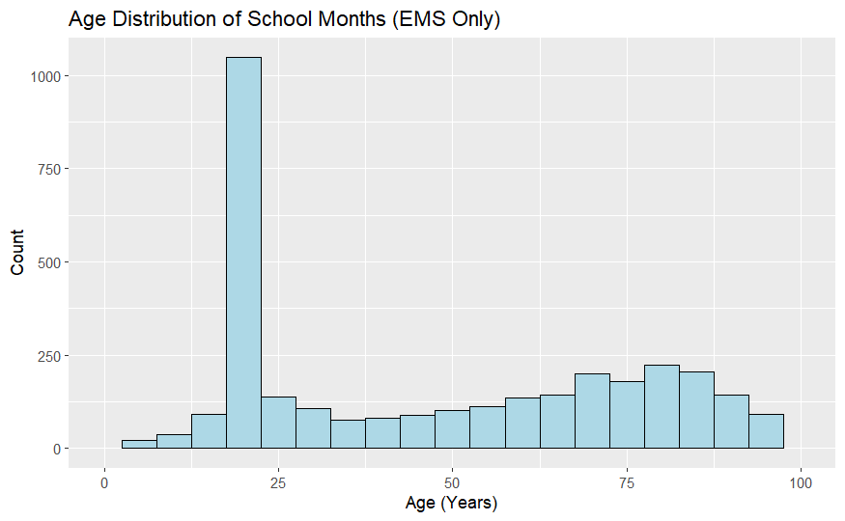
Figure 1.
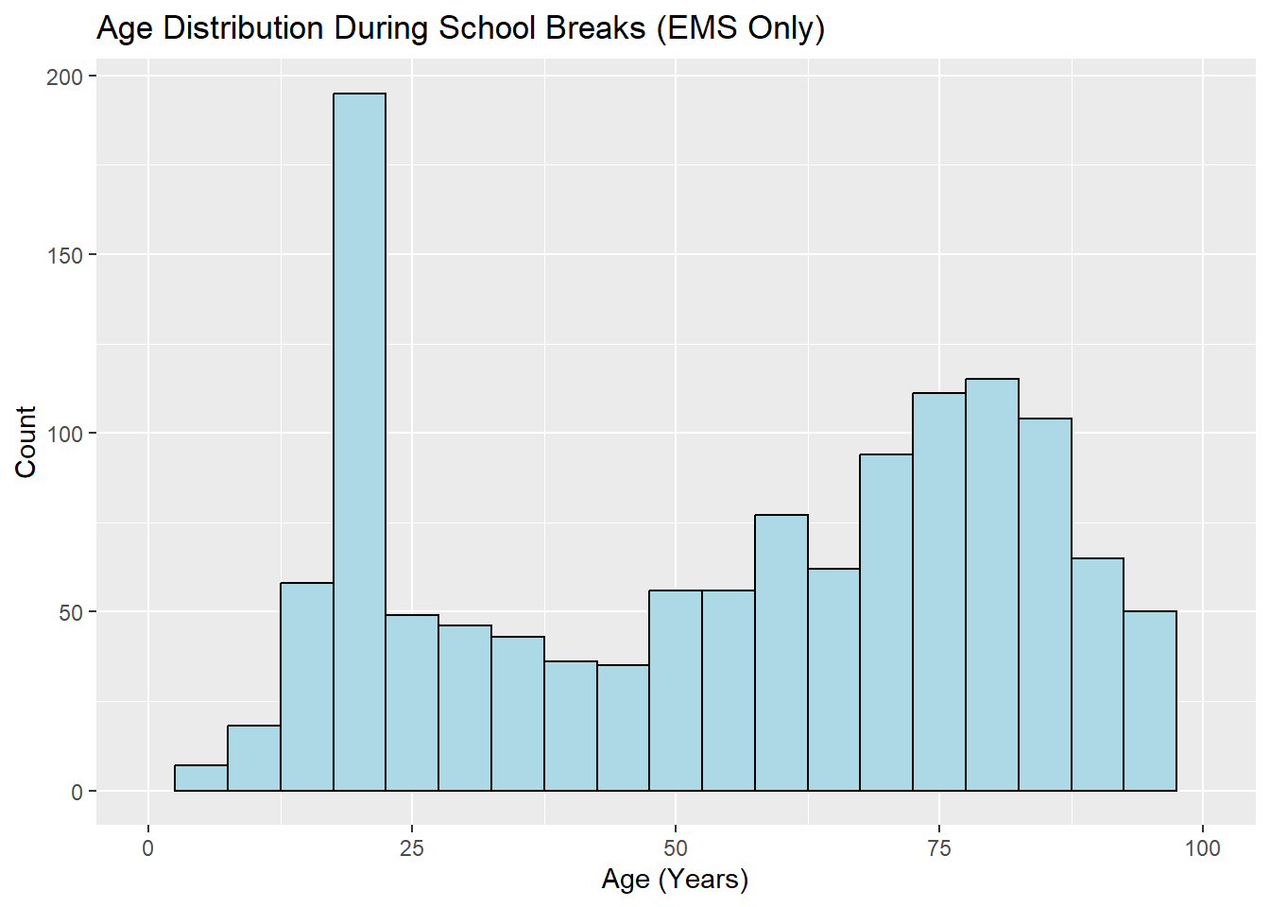
Figure 2.

5. Geographic Differences in Service Demand
Looking at different districts also showed clear differences. The City of Oxford had the highest number of calls, followed by Miami University and Milford Township. Age also varied by district. Areas near the university had younger patients, while surrounding areas had older populations. This shows that different areas have different needs. It also shows that service demand is not the same everywhere.
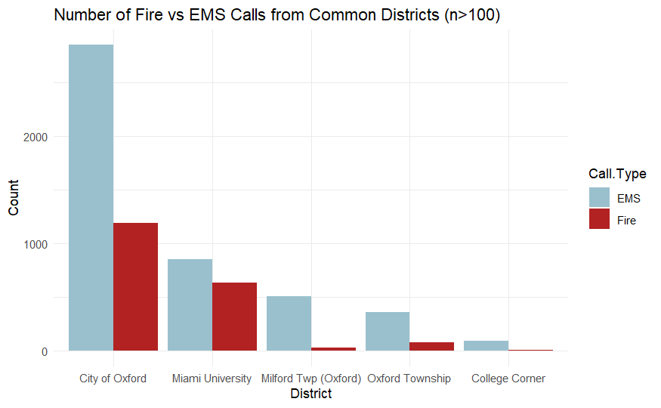
Figure 3.

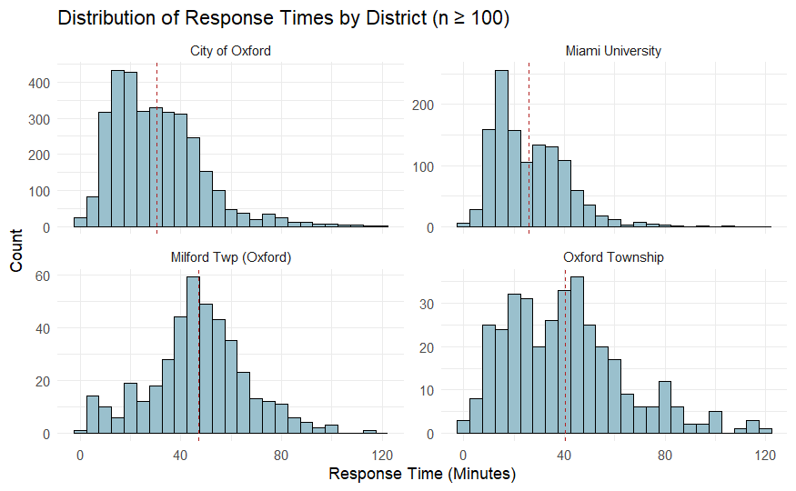
Figure 4.

6. Time Patterns in Emergency Calls
Time patterns were also very clear. Call volume is lowest early in the morning and increases throughout the day. The highest number of calls happens in the afternoon and evening. This pattern is seen in both EMS and fire data, although EMS calls happen more often overall. Looking at the days of the week, there are more calls later in the week. Fridays and Saturdays tend to have the highest volume. These patterns suggest that demand is somewhat predictable.
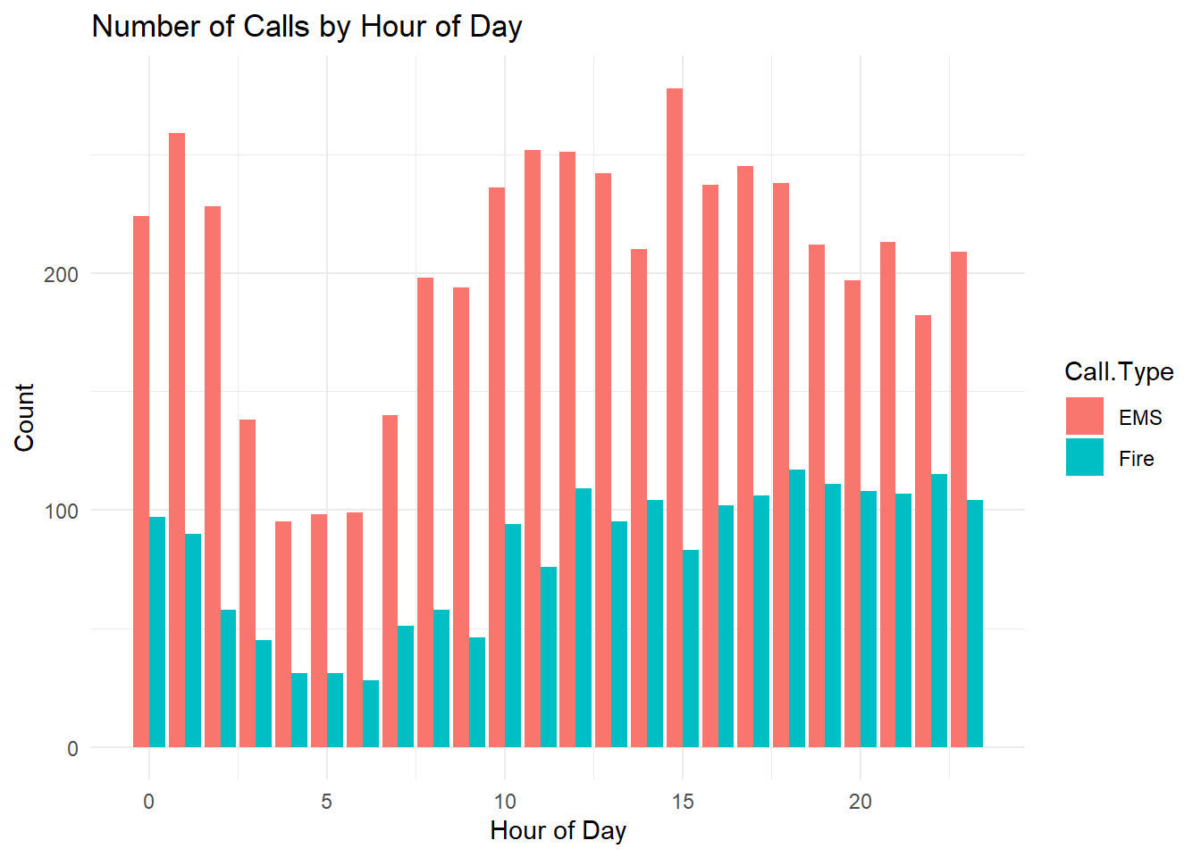
Figure 5.
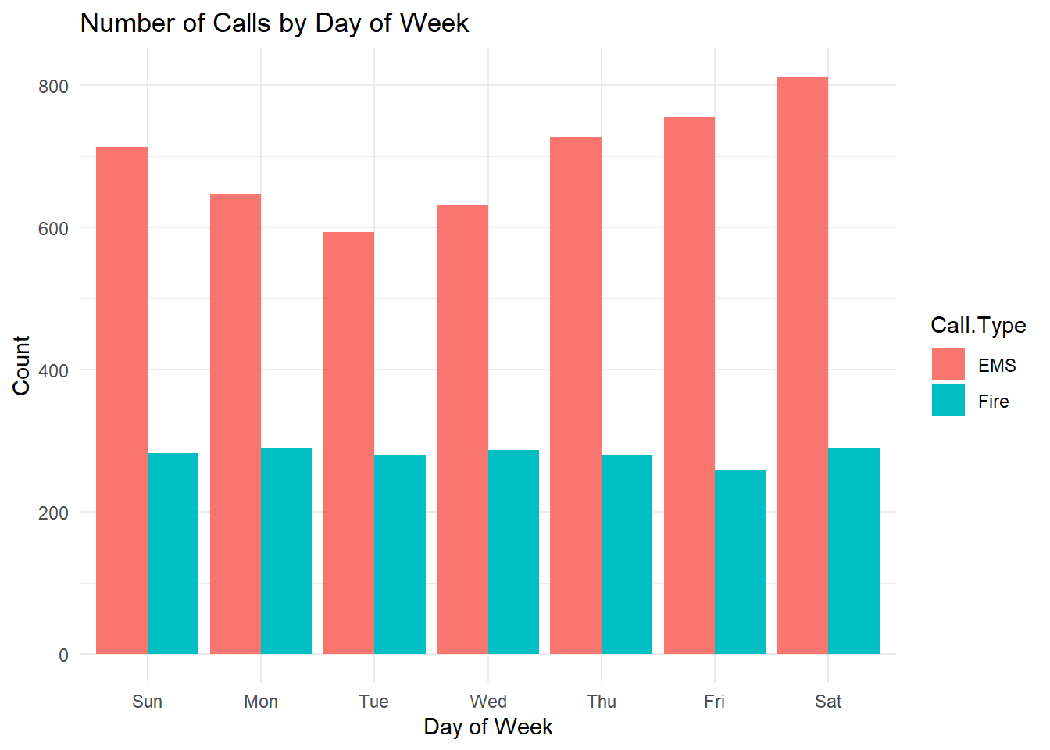
Figure 6.

7. Locations with Frequent Calls
Looking at specific locations also gave useful insights. EMS calls happen most often in schools, medical buildings, student dormitory buildings, apartment complexes and off-campus housing areas. This suggests a strong connection between population density and medical calls. Fire calls, on the other hand, are more common in places like dorms, institutional buildings, and businesses in Uptown Oxford. This shows that different environments are associated with different types of incidents.
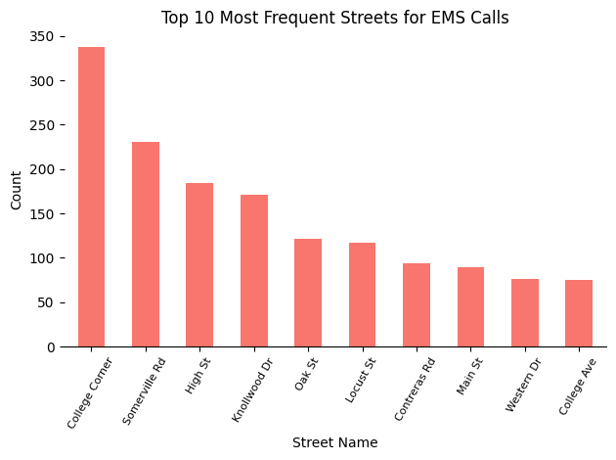
Figure 7.
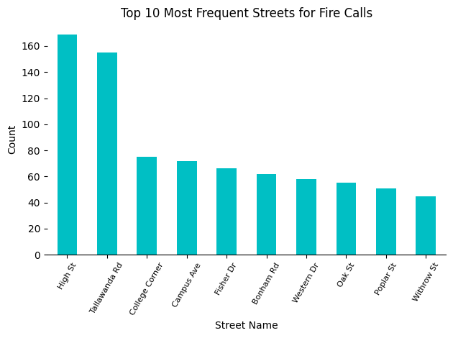
Figure 8.
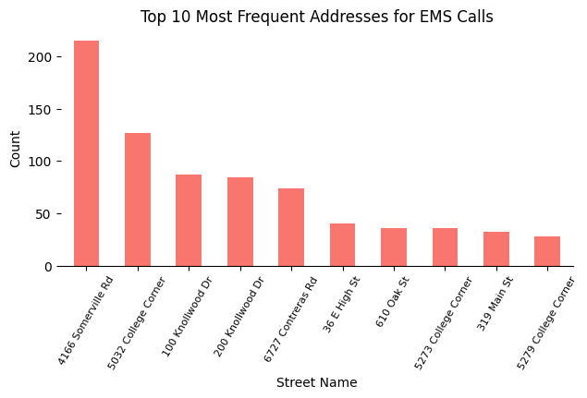
Figure 9.
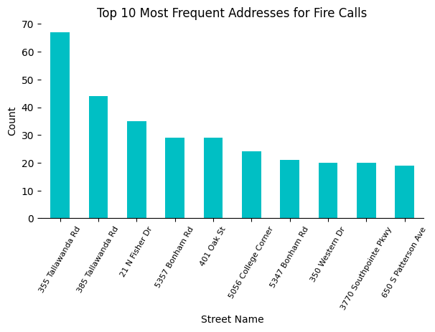
Figure 10.

8. Response Time Analysis
With the addition of the “Last Unit Cleared” data, it was possible to analyze response time more accurately. Fire calls showed a right-skewed distribution, meaning most calls were resolved fairly quickly, but some took much longer. This suggests that some incidents are more complex than others. EMS calls were more consistent in terms of time. Most EMS calls fell within a similar range. Being able to measure total time from call received to unit cleared gave a better understanding of how resources are used.
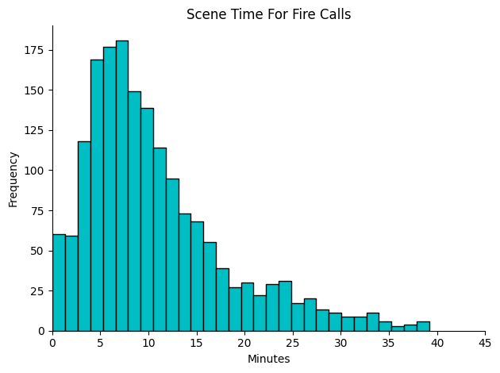
Figure 11.
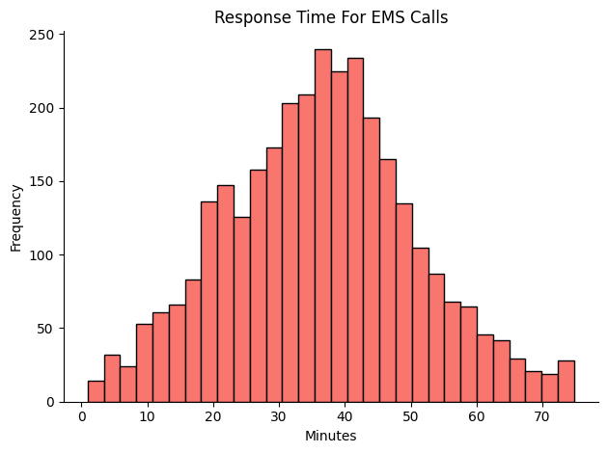
Figure 12.
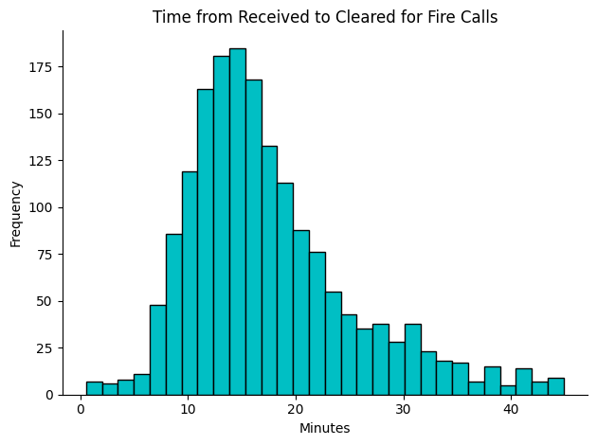
Figure 13.
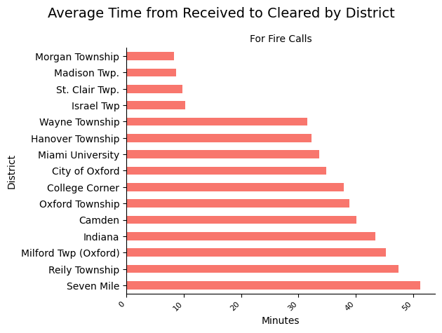
Figure 14.
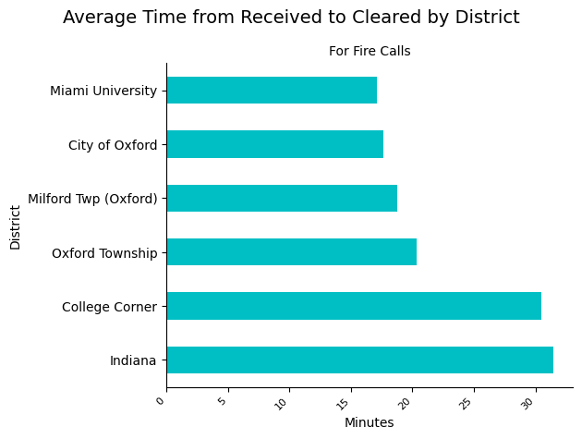
Figure 15.

9. Incident Type Analysis
Incident type was another variable that was important to explore, as different incident types, both fire and EMS, could have a large variation in response times. Depending on the call the station gets, the likelihood of getting an overlapping call increases with higher response times, as the fire engine needs time to re-prepare for the next call after completing one. Exploring what incidents are the most common can help prepare staff for the inevitability of overlapping calls. For the fire data, the most common incident types were equipment malfunctions, and for EMS, the patients were typically cared for as expected.
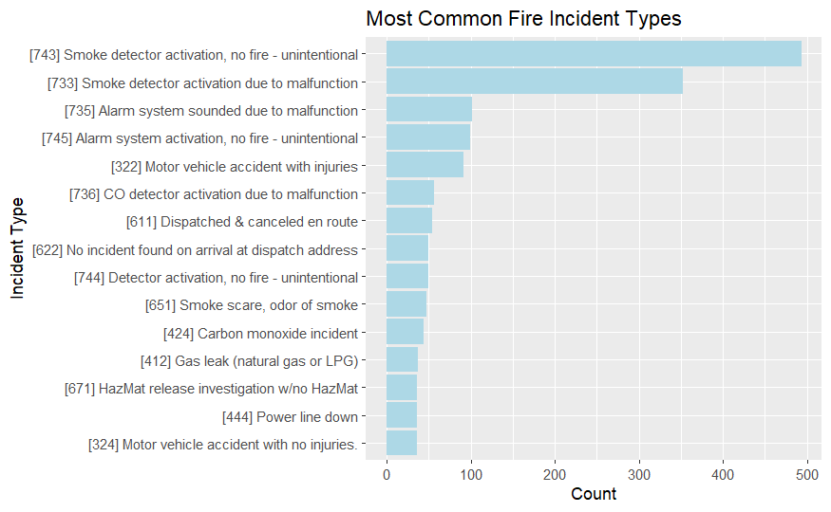
Figure 16.
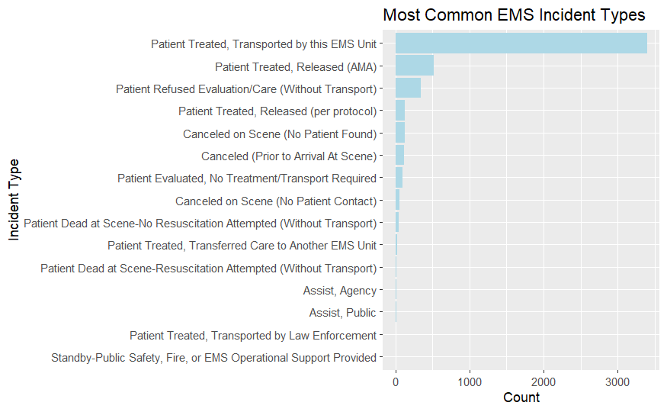
Figure 17.

10. False Alarm Analysis
False alarms were another important part of the EDA. Obviously, every call needs to be attended to in case of an emergency, but being able to properly identify and deal with false alarms quickly can help alleviate pressure of dealing with potential overlapping calls. The majority of false alarms were fire equipment malfunctions, with the remaining EMS false alarms being cancelled calls, either on scene or on the way to it. Most false alarms occurred during night and early morning hours, with no super clear trends by day of week.
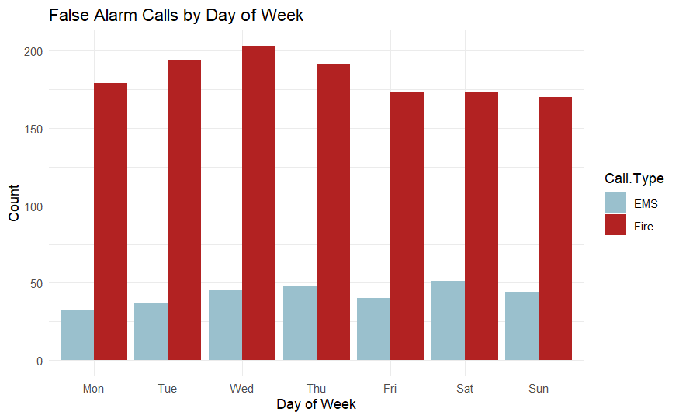
Figure 18.
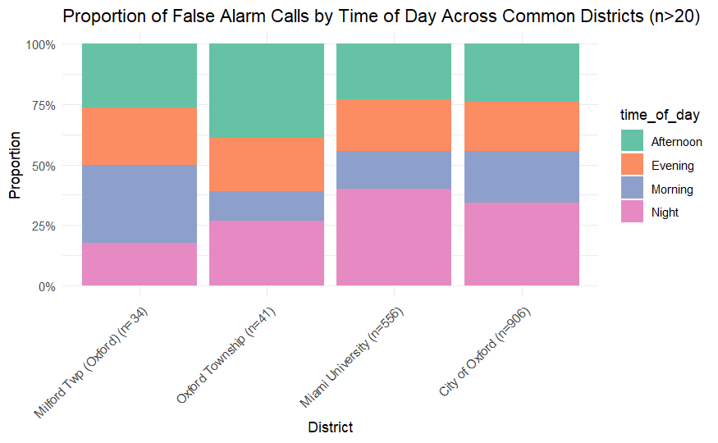
Figure 19.

11. District and Monthly Trends
Diving deeper into the discovery of trends, analyzing number of calls by time of day/month by district provided an excellent picture of the most common times calls occur and where they do occur. In terms of time of day, the most common districts follow the overall trends, with evening and early morning being the most common times to see calls. Expanding the analysis to the monthly level reveals that for the most common districts, September and October are the most populated months, likely due to the amount of student activity once people return to campus after summer breaks.
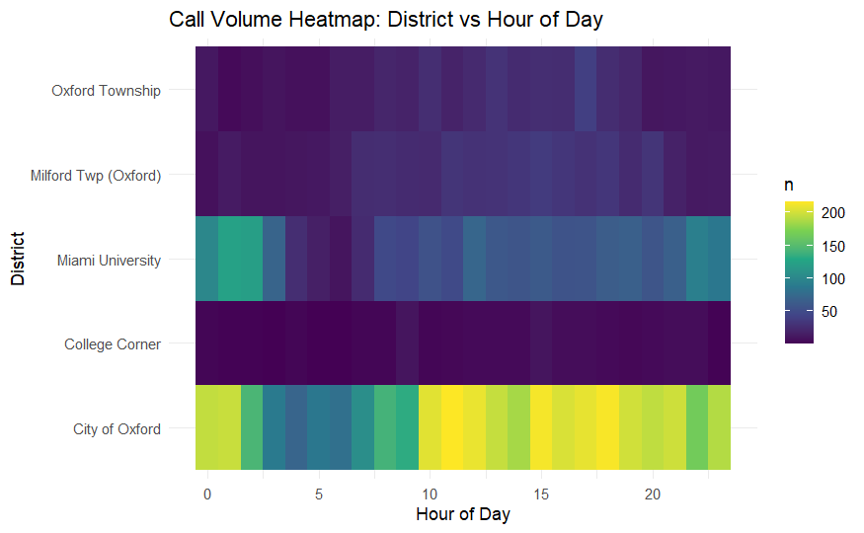
Figure 20.
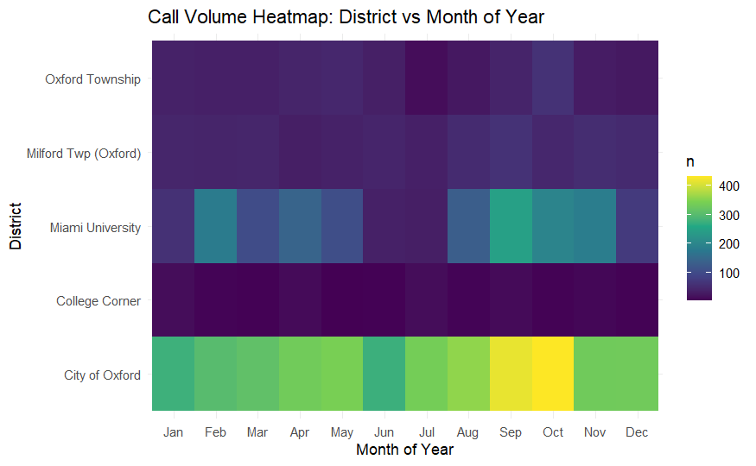
Figure 21.
12. Response Time Variation
The final part of the EDA was analyzing response times based on the multiple variables in the dataset. Chief Detherage mentioned in the preliminary discussion that this was one of his primary areas he valued seeing insights from, as by discovering what variables lead to longer response times can help allocate staffing properly so there is personnel to deal with any potential overlapping calls. The most variation in response times came from comparing fire vs EMS, as because a majority of fire calls handled equipment malfunctions, the response times were shorter on average. In terms of time of day, there wasn’t any significant variation in response time, as all calls, regardless of time of day, will receive the same proper attention. More specific variation came when breaking down the most common EMS call complaints, as different medical situations require different methods and thus varying time.
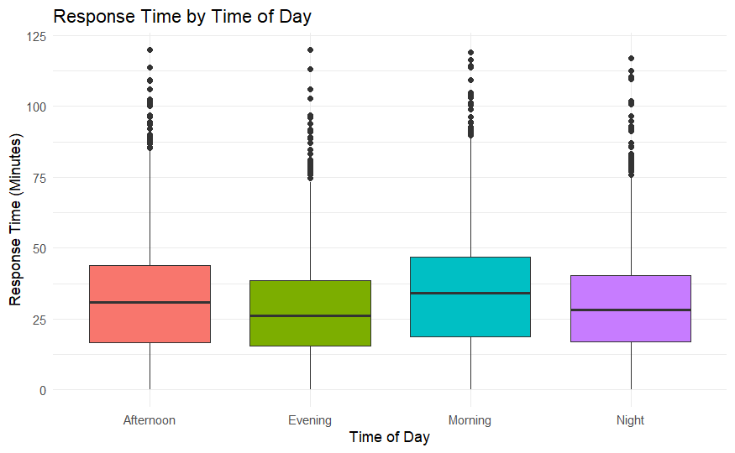
Figure 22.
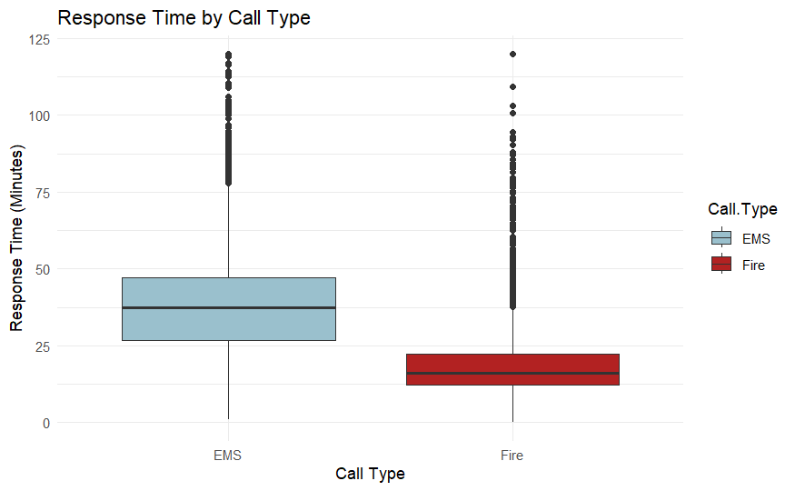
Figure 23.
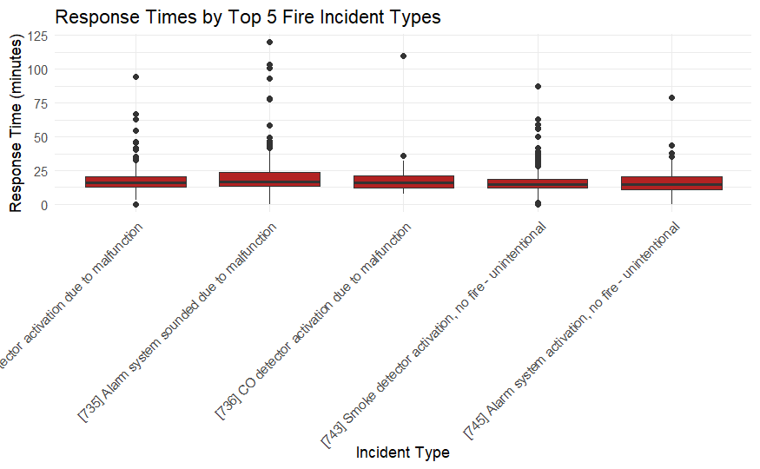
Figure 24.
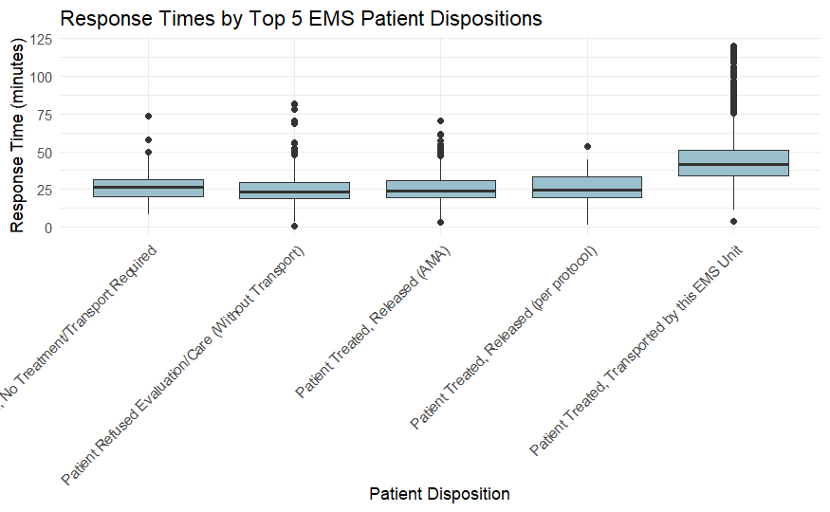
Figure 25.
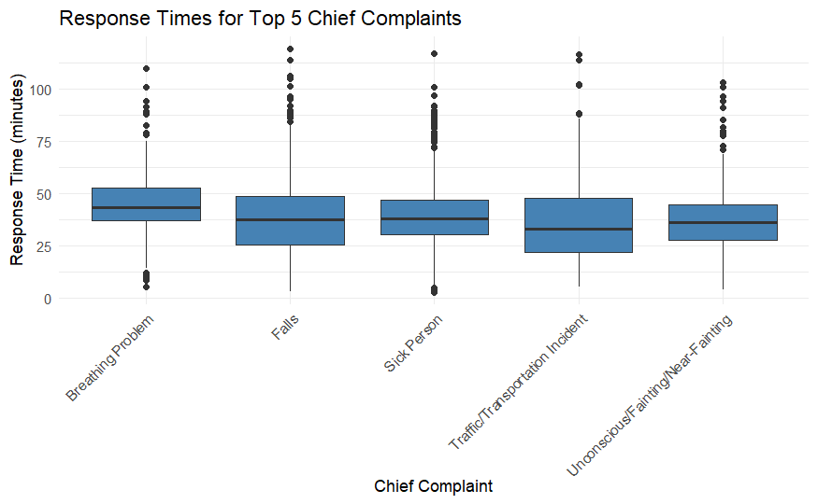
Figure 26.
13. Overlapping Call Analysis
While the earlier sections focused on call volume, response times, and geographic patterns, another important operational question is whether emergency calls occur simultaneously. When multiple incidents occur at the same time, the fire department must respond to several locations at once, which can increase pressure on available personnel and equipment. Understanding how often these overlapping situations occur helps provide insight into periods when resources may be stretched and coordination becomes more complex.
To better understand this situation, a more detailed analysis of overlapping calls was conducted using the cleaned and merged dataset that contains both EMS and fire call records. Two key timestamps were used for this analysis: the time when the call was received and the time when the last responding unit cleared the scene. These timestamps allow the duration of each incident to be identified and make it possible to determine whether other calls were active during that time period.
In order to represent operational conditions more realistically, an active call window was defined for each incident. This window begins at the time the call is received and extends until the time the last responding unit clears the scene. In addition, a 30 minute buffer period was added after the clearing time. This buffer accounts for the fact that emergency crews may still need time to return to service after clearing a call, including resetting equipment, completing documentation, or traveling back to their station. Including this additional time provides a more accurate representation of when resources may still be occupied and unavailable for new incidents.
After defining the active call window, the dataset was sorted chronologically based on the time each call was received. This ordering allows the analysis to evaluate calls in the exact sequence they occurred. A custom algorithm was then implemented to track which calls were active at the moment each new call arrived. The algorithm continuously monitored the set of active calls and removed calls once their active window had expired. When a new call was processed, the algorithm counted how many earlier calls were still active during that time.
Two additional variables were created to store the results of this process. The first variable records the number of active calls when each new call was received, which indicates how many incidents were already occurring at that moment. The second variable is a binary overlap indicator, where a value of 1 indicates that the call overlapped with at least one other active call and a value of 0 indicates that the call occurred without overlapping any other incident. This binary indicator makes it possible to easily summarize the frequency of overlapping calls across the dataset.
Using these variables, the overall overlap rate was calculated as the proportion of calls that occurred while another call was already active. The analysis then examined how overlap rates vary across time of day, district, and incident type. These additional breakdowns help identify when overlapping incidents are most likely to occur and where simultaneous demand on emergency resources is most common.
The results show that overlapping calls occur regularly throughout the service area. Although the average number of active calls at any given moment remains relatively low, there are clear periods when the likelihood of overlapping incidents increases. When examining the average number of active calls by hour of day, activity generally increases during the late morning and afternoon hours. The highest average number of active calls occurs around midday, suggesting that this period represents the time of greatest overall demand.
The overlap rate by hour of day provides additional insight into when simultaneous incidents are most likely to occur. While the overlap rate varies across the day, it remains relatively high during many hours, indicating that the department frequently manages multiple calls at the same time. Late evening and nighttime hours also show relatively high overlap rates, suggesting that even when total call volume is lower, incidents are still likely to occur while other calls are active.
The analysis also examined overlap rates across different districts within the service area. Some districts exhibit higher overlap rates than others, which may reflect differences in population density, call frequency, and types of incidents. Areas with higher call volume are naturally more likely to experience overlapping calls because incidents occur closer together in time. These geographic differences help highlight locations where simultaneous demand on resources may occur more frequently.
In addition to examining when and where overlapping calls occur, the analysis also explored the types of incidents involved in overlapping events. Overlapping incidents were categorized according to whether they involved EMS calls, fire calls, or a combination of both. The results show that the majority of overlapping events involve EMS calls occurring simultaneously with other EMS calls, followed by situations where an EMS call overlaps with a fire call. Overlaps involving two fire calls are less common, which is expected given that EMS calls occur more frequently overall.
Overall, several key patterns came out of the analysis. Service demand changes depending on time and location. Some times of day and days of the week are busier than others. Different areas have different types of calls and different populations. A large portion of fire calls are false alarms, which suggests there may be opportunities for prevention. Overlapping calls and high-frequency locations also show where demand is highest. There are some limitations to this analysis. Data quality may affect some results, especially since there are false alarms and incomplete records. Even with the added EMS clearance data, there may still be some variation in how data is recorded. Because of this, further analysis of overlapping calls was conducted to better understand when multiple incidents occur at the same time and how this affects operational demand.

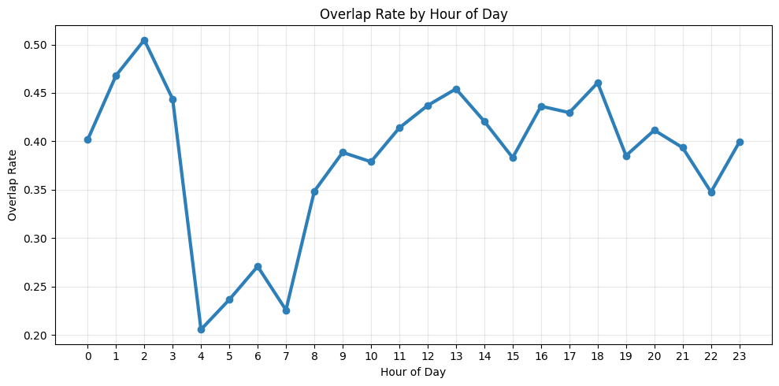
Figure 27.
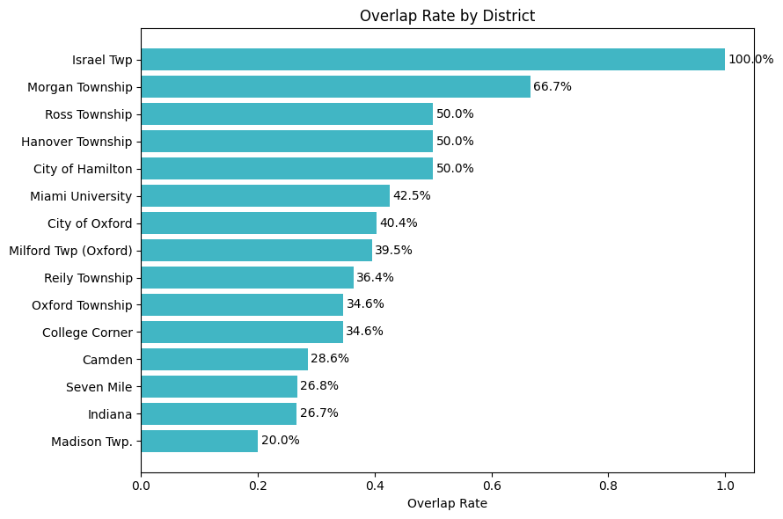
Figure 28.
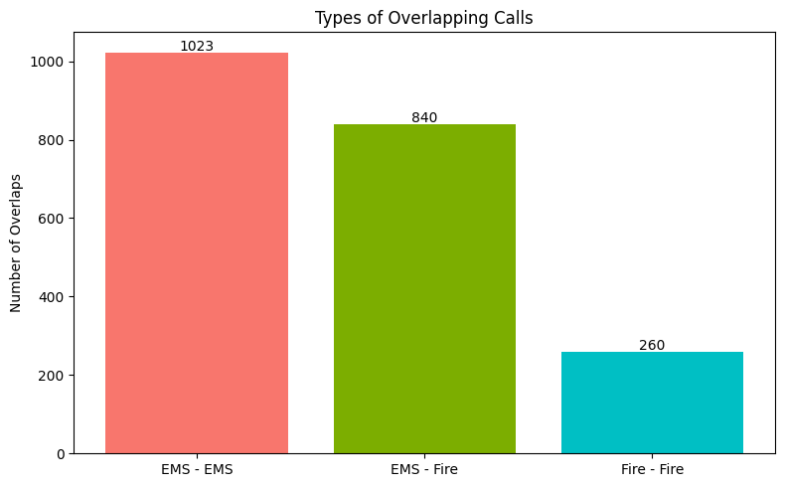
Figure 29.
This project shows how useful data analysis and visualization can be for understanding how emergency services actually work. By looking at patterns in time, location, and demographics, it becomes much easier to see what is driving service demand in the Oxford area. Instead of just looking at raw data, this approach helps turn the data into something more clear and meaningful. It also helps highlight trends, like when calls are most common and where they are happening the most. There is also room to build on this project in the future. Adding more years of data could help show trends more clearly over time. Predictive modeling could also be used to estimate future demand and help with planning ahead. Overall, this project provides a strong foundation for future analysis. It gives the Oxford Fire Department a clearer understanding of their operations and shows how data can be used in a practical way to support planning and resource allocation.

